**DAILY ONLINE ACTIVITIES SUMMARY**

|  |  |  |  |  |  |  |  |
| --- | --- | --- | --- | --- | --- | --- | --- |
| **Date:** | **18-06-2020** | | | | **Name:** | **B.A.SOHANKUMAR** | |
| **Sem & Sec** | **4TH SEM A** | | | | **USN:** | **4AL18CS013** | |
| **Online Test Summary** | | | | | | | |
| **Subject** | | **----** | | | | | |
| **Max. Marks** | | **----** | | **Score** | | **----** | |
| **Certification Course Summary** | | | | | | | |
| **Course** | **MACHINE LEARNING FOUNDATIONS** | | | | | | |
| **Certificate Provider** | | | **GLA** | **Duration** | | | **6 HOURS** |
| **Coding Challenges** | | | | | | | |
| **Problem Statement:1:Write a c program to generate first N magic numbers.**  **Problem Statement:2:Find the smallest positive integer value that cannot be represented as a sum of any subset as a given array sorted in ascending order.** | | | | | | | |
| **Status: EXECUTED** | | | | | | | |
| **Uploaded the report in Github** | | | | **YES** | | | |
| **If yes Repository name** | | | | **LOCKDOWN CODING** | | | |
| **Uploaded the report in slack** | | | | **YES** | | | |

**CERTIFICATION COURSE DETAILS:**

Course: Machine learning foundations

Today in this online course completed topics are Logistic Regression,Setting up Threshold,Performance Measures - Precision and Recall,Evaluation of Models,Hands on- Logistic Regression,Logistic Regression,pima-indians-diabetes,Gain and lift chart,Concordance and discordance ratio,Logistic Regression,Logistic Regression,Logistic Regression,evaluation of models,Logistic Regression and successfully completed the course.

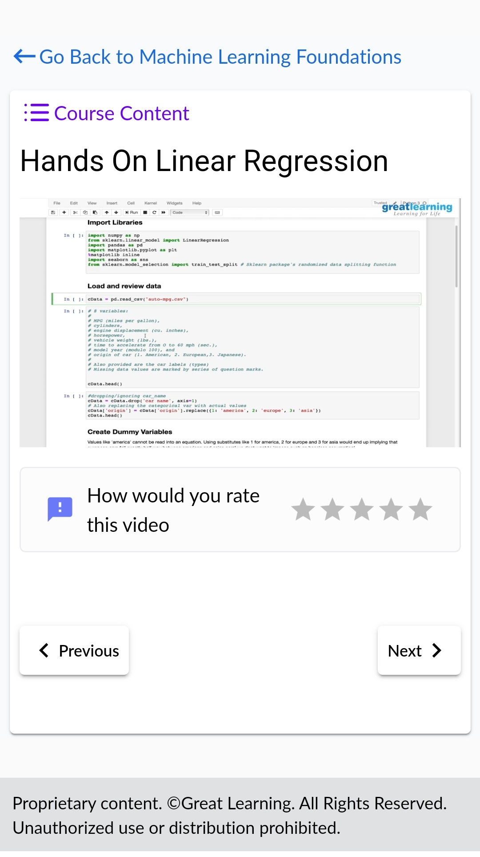 

**CODING CHALLENGES DETAILS:**

1.Write a C Program to generate first N Magic Numbers.A magic number is defined as a number which can be expressed as a power of 5 or sum of unique powers of 5. First few magic numbers are 5, 25, 30(5 + 25), 125, 130(125 + 5), ….

Input: n = 1

Output: 5

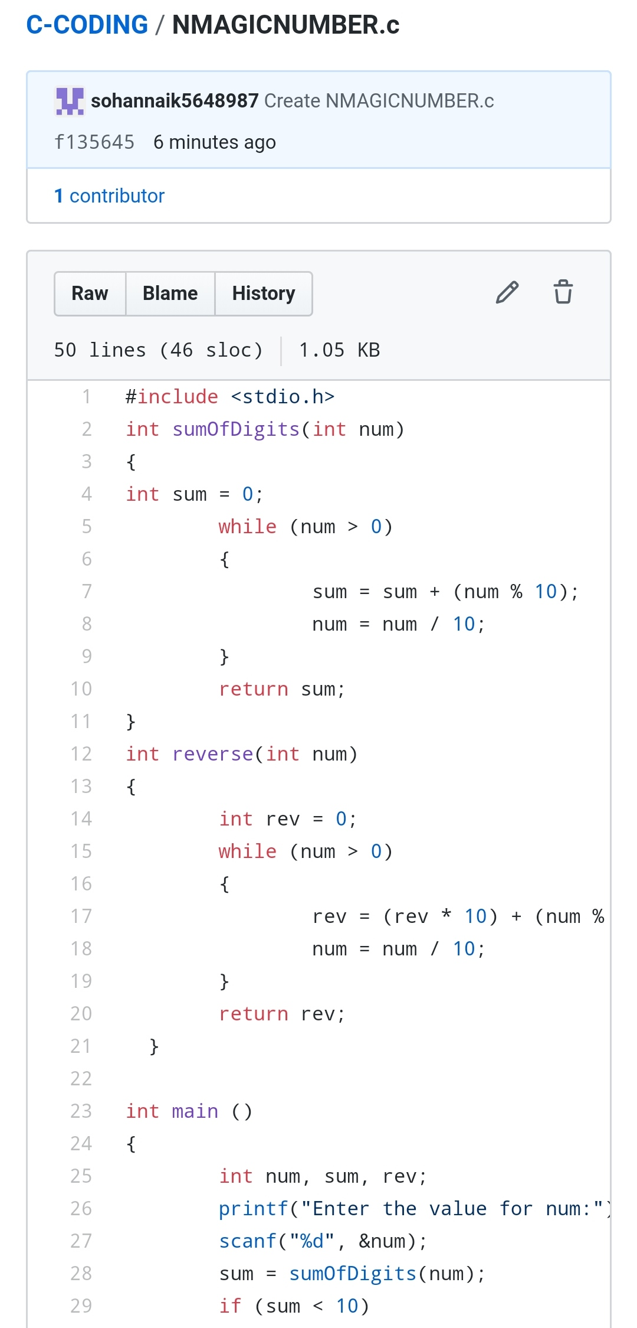

2Find the smallest positive integer value that cannot be represented as sum of any subset of a given array sorted in ascending order. Given a sorted array (sorted in non-decreasing order) of positive numbers, find the smallest positive integer value that cannot be represented as sum of elements of any subset of given set

Examples:Input: arr[] = {1, 3, 6, 10, 11, 15};

Output: 2

There are no one or more elements to be added up to get sum = 2

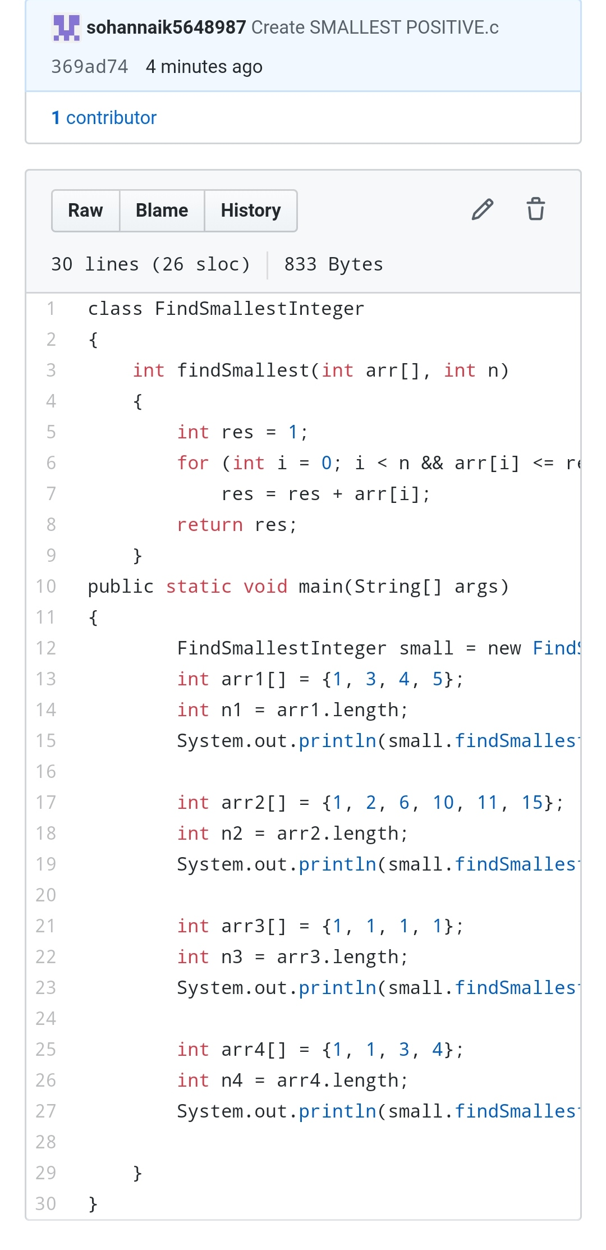

REPOSITORY LINK:https://github.com/sohannaik5648987/C-CODING